About the motor: Peak power is 15 Hp, which is 11 kW. At 50 V, that gives 223,7 A through all phases, so 100 A per phase should be much more than enough.
I’m assuming we’ll use a three-phase inverter (or what it would be called), which requires 6 transistors, that each must be able to conduct the phase current, and the drain-source must be greater than the battery voltage. We could use multi level inverters to use lower voltage mosfets (generally, R_{DS(on)} quadruples as V_{DS} doubles), but it’s a lot extra work, that I would like to avoid.
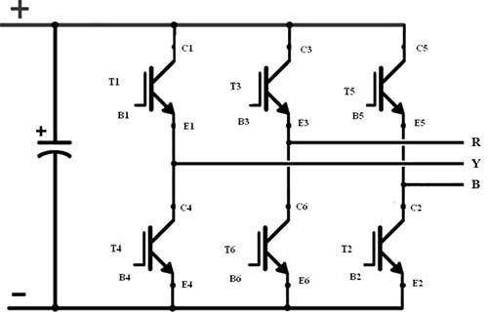
All prices listed are per piece for 100 transistors.
All transistor are SMD, to use the board for heat dissipation and inductances.
The names are links to their datasheet. To find the transistors, search for them on dk.farnell.com for the first three, and dk.rs-online.com for the last one (my preference)

INFINEON BSC028N06LS3 60 V, 100 A, 10,85 kr, Farnell. Pros: super low on-resistance of 2,8 mΩ. Cons: large input capacitance of 10 nF.
NXP PSMN1R4-30YLD 30 V 100 A 5,2 kr, Farnell. Pros: Even lower on resistans: 1,11 mΩ. Cons: Only 30 V, also even larger input capacitance of 27,6 nF.
INFINEON IPD034N06N3 G 60 V 90 A, 8,27 kr, Farnell. Pros: Fast switching (rise + fall = 17 ns). Cons: 4,8 mΩ.
BSC039N06NS 60 V, 100 A, 6,09 kr, RS. Pros: fast (19 ns), low R_{DS(on)} (3,9 mΩ), low input capacitance (2 nF), cheap. Cons: None, that I know of. Definitely my first choice.

